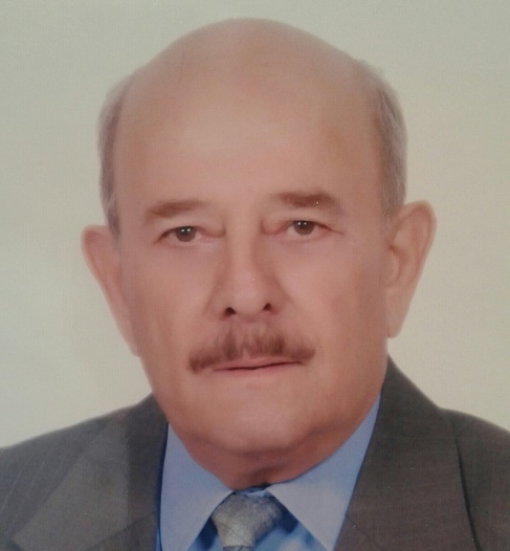

Hatem Najdi, BSc, MSc, PhD
Address: No. 5, Island 4, Sham Neighborhood, Damascus, Syrian Arab Republic.
E mail: hatemnajdi@gmail.com
Blog: http://hatemnajdi.blogspot.com
Tel: +963 11 3122549, Mobile: +963 932606734

Summery
He obtained a PhD Degree in digital communication from Loughborouhg University of Technology, UK, in 1982. He worked at the Scientific Studies and Research Center in Damascus, Syria from 1976 till 2017 where he participated in many research and development in digital communication, and taught at the Higher Institute for Science and Technology in Damascus. He occupied several leading positions at the Electronics Research Institute within the Scientific Studies and Research Center, and became a consultant to the Center General Director. He joined the Syrian Private University in 2017.

Qualifications
- PhD, “Digital Data Transmission on Voice Channels”, Loughborough University of Technology, UK.
- MSc, Digital Communication, Loughborough University of Technology, UK.
- BSc, Electronic Engineering, Damascus University.

Scientific positions
- Professor at the Syrian Private University.
1995-2017 Director of Research, Scientific and Research Center, Damascus, Syria.
1989-1994 Senior Researcher, Scientific and Research Center, Damascus, Syria.
  - Researcher, Scientific and Research Center, Damascus, Syria.

Managerial Positions
2004-2017 Consultant to the General Director of the Scientific and Research Center, Damascus, Syria.
2002-2003 Director of the Electronic Research Institute, Scientific and Research Center, Damascus, Syria.
1996-2002 Director of the Research and Development Branch at the Electronic Research Institute, Scientific and Research Center, Damascus, Syria.
1989-1994 Head of speech signal processing group, Scientific and Research Center, Damascus, Syria.

Awards
Award of the Custodian of the Holy Mosques for Translation, 2008.

Committees
Participated in and headed many specialized scientific committees within the Scientific Studies and Research Center.

Teaching
2017-2018 Data Communication, The Syrian Private University.
2017-2018 Information Theory, The Syrian Private University.
1983-2016 Data Acquisition Systems, Higher Institute for Science and Technology, Damascus, Syria.
1983-2016 Data Transmission Systems, Higher Institute for Science and Technology, Damascus, Syria.
1983-2016 Computer Networks, Higher Institute for Science and Technology, Damascus, Syria.
1983-2016 Continuous education courses in Cryptography and Data Security, Higher Institute for Science and Technology, Damascus, Syria.

Scientific Translation (English to Arabic)
Magazines
1987-2016 Scientific American, for Al Oloom in Kuwait.
2013-now Nature, for Nature Arabic Edition in Cairo.
2016-now Scientific American, for “Scientific American للعلم”.

Text & Reference Books
2015 Advances in HealthcareTechnology, Shaping the Future of Medical Care, Edited by Gerhard Spekowius & Thomas Wendler, Translation published by Arab Organization for Translation, Beirut.
2015 Agriculture Research & Technologies, Kristian Bundgaard and Luke Isaksen, Translation published by Arab Organization for Translation, Beirut.
2013 Construction Technology: Analysis and Choice, Tony Bryan, Translation published by Arab Organization for Translation, Beirut.
2013 Introduction to Agricultural Engineering Technology: A Problem Solving Approach, Harry L. Field and John B. Solie, Translation published by Arab Organization for Translation, Beirut.
2012 Electronics and Communications for Scientists and Engineers, Martin Plonus, Translation published by Arab Organization for Translation, Beirut.
2012 Review of the translations of chapters 8-15 of Introduction to Nanoscale Science and Technology, David J. Lockwood, Translation published by Arab Organization for Translation, Beirut.
2011 New Materials: Processes, Methods and Technology, Mel Shwartz, Translation published by Arab Organization for Translation, Beirut.
2011 Nanotechnology: A gentle Introduction to the Next Big Idea, Mark and Daniel Ratner, Translation published by Arab Organization for Translation, Beirut.
2011 Bioengineering Fundamentals, Ann Saterbak, Larry McIntire and Ka-Yiu San, Translation published by Arab Organization for Translation, Beirut.
2011 Environmental Chemistry, Gary van Loon and Stephen Duff, Translation published by Arab Organization for Translation, Beirut.
2008 System Engineering Management, Benjamin Blanchard, Translation published by Arab Organization for Translation, Beirut, 2007. The book won the Award of the Custodian of the Holy Mosques for Translation.
2006 Applied Cryptography, Bruce Schneir. Translation published by Syrian Computer Society.

Cultural Scientific books
2018 The Inevitable, Kevin Kelly, Translation finished, ready for publication, 2018.
2018 What Technology Wants, Kevin Kelly, Translation published by Kuwait Foundation for Science Advancement, Kuwait, 2018.
2014 Where Good Ideas Come From: The Natural History of Innovation, Steven Johnson, Translation published by Kuwait Foundation for Science Advancement, Kuwait, 2014.
1998 Black Holes and Baby Universes, Stephen Hawking, Translation published by Dar Tlas, Damascus, 1998.
1998 Darkness at Night, a riddle of the Universe, Edward Harriso, Translation published by Dar Tlas, Damascus, 1998.
1990 Other Worlds, Paul Davis, Translation published by Dar Tlas, Damascus, 1990.

Authored book
2017 Prominent Milestones in the History of Human Innovations. http://hatemnajdi. blogspot.com, 2017

Conferences and Scientific Occasions
- Attended more than 40 scientific occasions, conferences and continuous education courses over 40 years of working at the Scientific Studies and Research Center.
- Presenting semi-monthly cultural and specialized lectures within the Scientific Studies and Research Center.

Languages
English

Academic Societies
The Syrian Computer Society.

